Heart disease is one of the most common cause of death among Filipinos. “21 percent of Filipino adults are hypertensive,” said Dr. Dante Morales, President of the Philippine Society of Hypertension (PSH) during the National Hypertension Awareness celebration conducted at the Universidad De Manila on 19 May 2012.

Blood Pressure is the pressure circulating blood on the walls of blood vessels. Blood pressure is usually expressed in terms of the systolic pressure (maximum during one heart beat) over diastolic pressure (Minimum in between two heart beats) and is measured in millimeters of mercury (mmHg). Normal resting blood pressure in an adult is approximately 120 mmHg systolic, and 80 mmHg diastolic, abbreviated “120/80 mmHg”. Blood pressure has two states the low blood pressure also known as the hypotension and hypertension for the high blood pressure. Long term hypertension can affect the body it is a risk factor for many diseases, including heart disease, stroke, and kidney failure. Pulse rate is one of the vital signs. It is the number of times per minute that the heart contracts or beats. The resting pulse rate is the rate where you’re sitting or lying and when you’re calm it is said that the pulse rate is normally between 60 (beats per minute) and 100 (beats per minute).

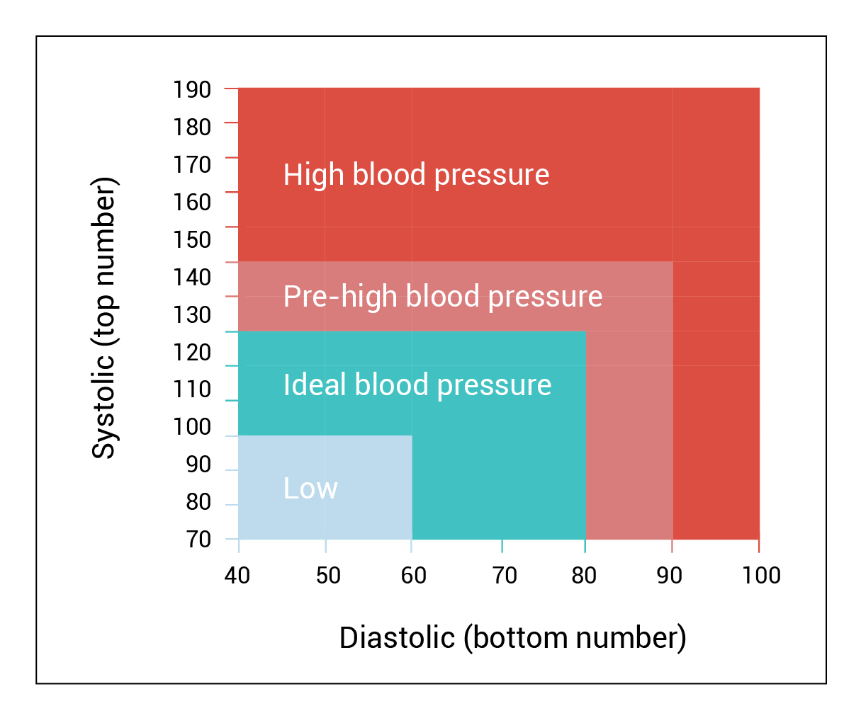

**Fig. I General Blood Pressure Chart**

Blood pressure and Pulse rate are interrelated components of the cardiovascular system and therefore, not mutually exclusively. One can affect another according to, ”Dr. Shelby-Lane. If the blood pressure is not monitored properly the arteries and the vital organs in the body will be damaged causes heart attack, stroke, heart failure, aneurysm or renal failure. Which means there is a need for the patients’ family members, friends and communities to involve in the care activities.

Monitoring of the blood pressure is important for the vital prevention and treatment of blood pressure related disease. Additionally, in very ill patient, accurate measurement of blood pressure is essential for monitoring cardiovascular homeostasis. The traditional way of measuring of blood pressure is with the use of cuff has a gauge on it that will read your blood pressure. Then the doctor or nurse will inflate the cuff to squeeze your arm.

After the cuff is inflated, the doctor or nurse will slowly let air out. While doing this, he or she will listen to your pulse with a stethoscope and watch the gauge. The gauge uses a scale called "millimeters of mercury” (mmHg) to measure the pressure in your blood vessels.

Blood pressure is measured using two numbers. The first number, called **systolic** blood pressure, measures the pressure in your blood vessels when your heart beats. The second number, called **diastolic** blood pressure, measures the pressure in your blood vessels when your heart rests between beats.

If the measurement reads 120 systolic and 80 diastolic, you would say "120 over 80" or write "120/80 mmHg."

A blood pressure less than 120/80 mmHg is normal. A blood pressure of 140/90 mmHg or more is too high. People with levels in between 120/80 and 140/90 have a condition called prehypertension, which means they are [at high risk for high blood pressure](https://www.cdc.gov/bloodpressure/risk_factors.htm). The chart below shows normal, at-risk, and high blood pressure levels based on the patient age.

|  |  |  |  |  |  |  |  |  |  |  |
| --- | --- | --- | --- | --- | --- | --- | --- | --- | --- | --- |
| **Age** | **Hypotension (low blood pressure)** | | **Normal BP** | | **Prehypertension** | | **Hypertension Stage 1** | | **Hypertension Stage 2** | |
|  | S | D | S | D | S | D | S | D | S | D |
| 17-19 | < 90 | < 60 | <120 | <85 | <120 | <80 | <140 | <89 | <150 | <100 |
| 20-24 | < 90 | < 60 | <120 | <79 | <125 | <82 | <140 | <85 | <150 | <100 |
| 25-29 | < 90 | < 60 | <121 | <80 | <132 | <83 | <140 | <88 | <150 | <100 |
| 30 – 34 | < 90 | < 60 | <122 | <81 | <134 | <85 | <140 | <90 | <160 | <100 |
| 35 – 39 | < 90 | < 60 | <123 | <82 | <135 | <86 | <142 | <91 | <162 | <101 |
| 40 – 44 | < 90 | < 60 | <125 | <83 | <137 | <87 | <144 | <92 | <164 | <102 |
| 45 – 49 | < 90 | < 60 | <127 | <84 | <139 | <88 | <146 | <93 | <166 | <103 |
| 50 – 54 | < 90 | < 60 | <129 | <85 | <141 | <89 | <148 | <94 | <168 | <104 |
| 55 – 59 | < 90 | < 60 | <131 | <86 | <143 | <90 | <150 | <95 | <170 | <105 |
| 60+ | < 90 | < 60 | <134 | <87 | <146 | <91 | <153 | <96 | <173 | <106 |

**Fig. 1.2 Blood Pressure Chart by Age**

*S = Systolic Pressure*   
*D = Diastolic Pressure*